**Signboard Translation From Vernacular Languages**

### A PROJECT REPORT

***Submitted by***

**VISHNU TEJA CHIKKALA [RA1711003030378]**

**RAJPREET SRIVASTAV [RA1711003030380]**

*Under the guidance of*

## MR. Sunil Kumar

(Assistant Professor, Department of Computer Sciene & Engineering)

***in partial fulfillment for the award of the degree of***

### BACHELOR OF TECHNOLOGY

in

## COMPUTER SCIENCE & ENGINEERING

of

### FACULTY OF ENGINEERING AND TECHNOLOGY



#### SRM INSTITUTE OF SCIENCE & TECHNOLOGY, NCR CAMPUS

**MAY 2021**

SRM INSTITUTE OF SCIENCE & TECHNOLOGY

(Under Section 3 of UGC Act, 1956)

## BONAFIDE CERTIFICATE

#### Certified that this project report titled **Signboard Translation from Vernacular Languages** is the bonafide work of **VISHNU TEJA CHIKKALA [RA1711003030378], RAJPREET SRIVASTAV [RA1711003030383]** who carried out the project work under my supervision. Certified further, that to the best of my knowledge the work reported herein does not form any other project re- port or dissertation on the basis of which a degree or award was conferred on an earlier occasion on this or any other candidate.

##### SIGNATURE

MR.SUNIL KUMAR

##### GUIDE

Assistant Professor

Dept. of Computer Science & Engineering

Signature of the Internal Examiner

##### SIGNATURE

Dr. R.P.MAHAPATRA

##### HEAD OF THE DEPARTMENT

Dept. of Computer Science & Engineering

Signature of the External Examiner

# ABSTRACT

India has 22 constitutionally recognized languages written in 13 different scripts. An average traveler, on a business trip, when travelling to a new region, might often get confused with signboards written in an unfamiliar language. It is also impossible to have every signboard in every city / town / village written in 22 different languages, as there will not be enough room to accommodate more than 2 – 3 scripts.

The objective of this project is to develop a simple, easy-to-use and scalable Android mobile app which provides a two-click, picture-to-text, translation / transliteration service for Indian vernacular languages, using deep neural networks and natural language processing models trained for text detection, recognition and translation tasks on collected and freely-available datasets, using frameworks such as PyTorch and Tensorflow.

For the scope of this project, we will design a system which works for names (such as road names, city names, shop names, organization names, etc.) which typically are not longer than 4-5 words, and support translation for 1 language. Further scope for the project involves including support for more languages and building models to support translation / transliteration of longer pieces of text

**ACKNOWLEDGEMENT**

We would like to express our deepest gratitude to our guide, **MR. SUNIL KUMAR** for his valuable guidance, consistent encouragement, personal caring, timely help and providing us with an excellent atmosphere for doing research. All through the work, in spite of his busy schedule, he has extended cheerful and cordial support to us for completing this research work.

##### Authors

**TABLE OF CONTENTS**

**Abstract iii**

**Acknowledgement iv**

**List of Tables vi**

**List of Figures vii**

1. **INTRODUCTION 1**
2. **LITERATURE REVIEW 2**
3. **METHODOLOGY 4**
4. **SYSTEM ACRCHITECTURE 11**
5. **PROJECT CODE AND RESULTS 12**
6. **CONCLUSION 43**
7. **SCOPE FOR FUTURE 44**
8. **REFERENCES 45**

**LIST OF TABLES**

1**.** List of Proposed Models 3

**LIST OF FIGURES**

1. Synthetically Generated Training Image 4
2. Training Annotation 5
3. COCO Format Annotation 5
4. Detection / Recognition Test Image 6
5. Transliteration Dataset 6
6. Detectron2 Faster RCNN 7
7. CNN-GRU Text Recognition Model 8
8. GRU-GRU Text Transliteration Architecture 9
9. App Interface 10
10. App Architecture 11
11. Model Architecture 11

**ABBREVIATIONS**

**ANN** - Artificial Neural Network

**CNN** - Convulutional Neural Network

**RNN -** Recurrent Neural Network

**GRU -** Gated Recurrent Unit

**CTC** - Connectionist Temporal Classification

**NITS-LD** - NIT Silchar Language Database

**OGI-MLTS** - OGI-Multilingual Database

**RRNN -** Regression Residual Neural Network

**NLP -** Natural Language Processing

**COCO -** Common Objects in Context

**FPN -** Feature Pyramid Network

**ROI -** Regions of Interest

**SVM -** Support Vector Machines

**CHAPTER 1**

**INTRODUCTION**

* 1. **Project Overview**

The project describes the process of creating an end-to-end stack of neural network models, to perform the tasks of text detection, text recognition and text transliteration in order to extract text of the source language from an image, and output transliterated text in the target language. For this purpose, three models are built:

* a Region-based Convolutional Neural Network for performing text detection (a subset task of object detection with class 'text')
* a Convolutional Neural Network (CNN) - Recurrent Neural Network (RNN) / Gated Recurrent Unit (GRU) Encoder-Decoder Architecture for performing text recognition
* a GRU - GRU Encoder-Decoder Architecture for performing text transliteration

This models will then be trained on a custom dataset featuring a large number of synthetically generated scene-text images, as well a collection of natural scene-text images, along with annotations describing bounding boxes and ground truth source script. The transliteration model will be trained on another dataset which includes large number of source script words and their corresponding target script words.

This model will then be compiled into an end-to-end stack using TensorflowLite and deployed onto an Android app developed in Java.

**CHAPTER 2**

**LITERATURE REVIEW**

**2.1 Summary of Literature Review**

C.Kurian et al. concluded that the Indian community faces a “Digital Divide” due to dominance of English as mode of communication in higher education, judiciary, corporate sector and Public administration at Central level whereas the government in states work in their respective regional languages[1].

From the 2011 Census of India, it is observed that. while 99 % of the population speak one of these scheduled languages in various dialects (which number in the thousands), according to Census 2011, the total percentage of English speakers is at 10 %, and that too is skewed towards the urban population [2].

N.P. Desai et al noted that traditionally NLP had been approached with statistical methods such as Hidden Markov Machines (HMM), Support vector machine(SVM), Conditional Random Field(CRF), Naive Bayes(NB), etc, which take a large amount of tagged/annotated data (corpus) to statistically analyze and learn the language characteristics , and suggested that deep learning methods or a ‘connectionist approach’ could return better results[3]. The reasons for the same suggested by them and other authors, in brief, were -

1. the simplicity of the solution in rapidly prototyping and establishing practically effffective systems
2. the lower cost of annotation of the training data [4],
3. they attempt to more closely emulate the learning process of biological brains [3] [5] [6], among other reasons.

However, A. Kunchukuttan et al., note that the collection of a uniform corpus and standard datasets for training models remains a challenge across all regional languages. The large number of morphological variations across Indic languages also contributes to this issue[7]. This study also proposed the creation of a “large-scale, general-domain” corpus for 10 Indian Languages across 2 scripts[7]. J. Philip et al., in their study, also highlighted several efforts at collating standard datasets and corpora for Indian languages[4].

Sharma et al., 2017 concluded that almost all existing Indian language machine transliteration systems are based on statistical and hybrid approach[8].

A few models proposed in this field are as follows-

|  |  |  |
| --- | --- | --- |
| **Authors** | **Model** | **Accuracy** |
| Bhanja et al., 2019 [9] | CNN-LSTM Architecture using ResNet | 93% (NITS-LD), 89% (OGI-MLTS) |
| J. Philip et al, 2019 [4] | IL-Multi, | 34% (cold-start), 40% (with transferred learning) |
| Arafat, S. Y. et al, 2020 [10] | FasterR-CNN - CNN - RRNN Architecture | 99% |

Table 1 List of Proposed Models

**2.2 Research Gap**

From the above literature review, we conclude that there lies a need for developing NLP architectures for facilitating flow of digital content and information in and between local, national and international levels.

The above also means that a large percentage of the literate population is either monolingual or bilingual, and across 22 languages, an accessible, easy-to-use and intuitively developed system is required, which enables intercommunication.

A research gap that we identified was that, though several successful efforts have been made to develop computer vision and natural language processing (NLP) models for working with Indian languages, the corpora and the model techniques used are scattered and are not easily avaliable for general purpose training and use. Thus, with this project, we aimed to develop a standard, general model framework / architecture that could be trained quickly on multiple languages, given sufficient dataset and corpora resources.

**CHAPTER 3**

**METHODOLOGY**

This chapter discusses the methods, algorithms and techniques used to achieve the project objective in a serialized manner. In short, these steps, in order, are the preparation of datasets to be used with models, defining a model for text detection, from this detected piece of text performing text recognition to extract the script as a string, then transliterate this script into target language script. These trained models are then deployed as part of the mobile app to run inference on user-captured images.

**3.1 Model Framework**

The model framework is comprised of three models which are stacked end-to-end. This means that the output of the first model is formatted and directly fed as input to the second model and so on. All the models are trained independently for achieving higher training accuracy, while the stack of models for text detection and text recognition are both trained end-to-end as well, for tighter bounding box generation and text extraction..

**3.1.1 Data Collection and Preprocessing**

The training dataset for the text detection and text recognition tasks consists of a large number of images containing scene text,synthetically generated. Each of the images has a corresponding annotation, listing the bounding boxes (in RBOX form) and ground truth text script present in the images.

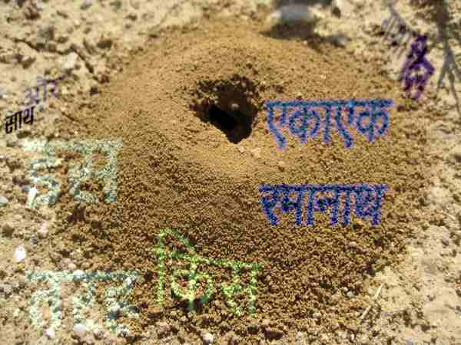

Figure 1: Synthetically Generated Training Image

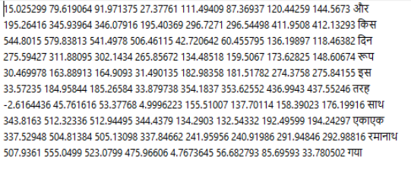

Figure 2 Training Annotation

For the text detection model, since we are using a model pretrained on the COCO dataset, we format the annotations of the whole dataframe into a JSON file, converted into the COCO format, specifically the BoxMode.XYWH_ABS format.

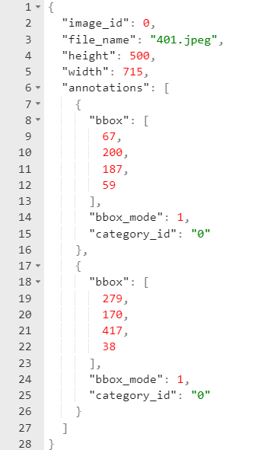

Figure 3 COCO Format Annotation

We have a set of 100k images and their corresponding images available, collected from open sources. However, for experimental purpose we curate a random batch of 2520 images for training, 255 images for validation and 407 images for testing. The ground truth for these images as Hindi script, which is our source script,, while our target script is English.

The test dataset for text detection and text recognition tasks consists of actual images containing natural scene text.

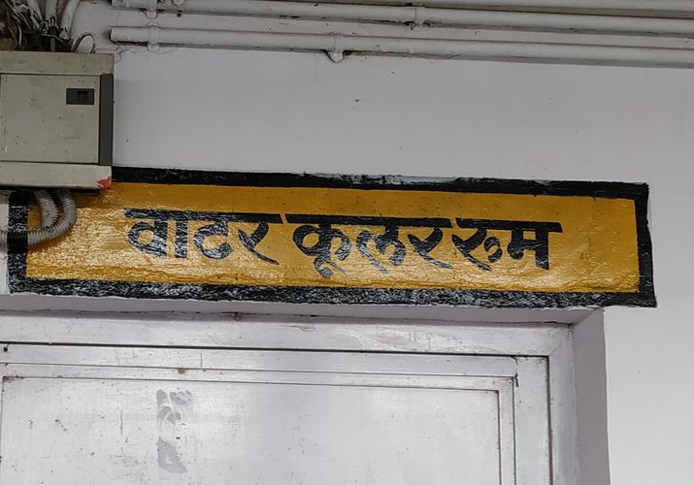

Figure 4 Detection / Recognition Test Image

The train and test datasets are both in form of xml files containing serialized pairs of source language script and corresponding target language script. (Hindi to English in this case)

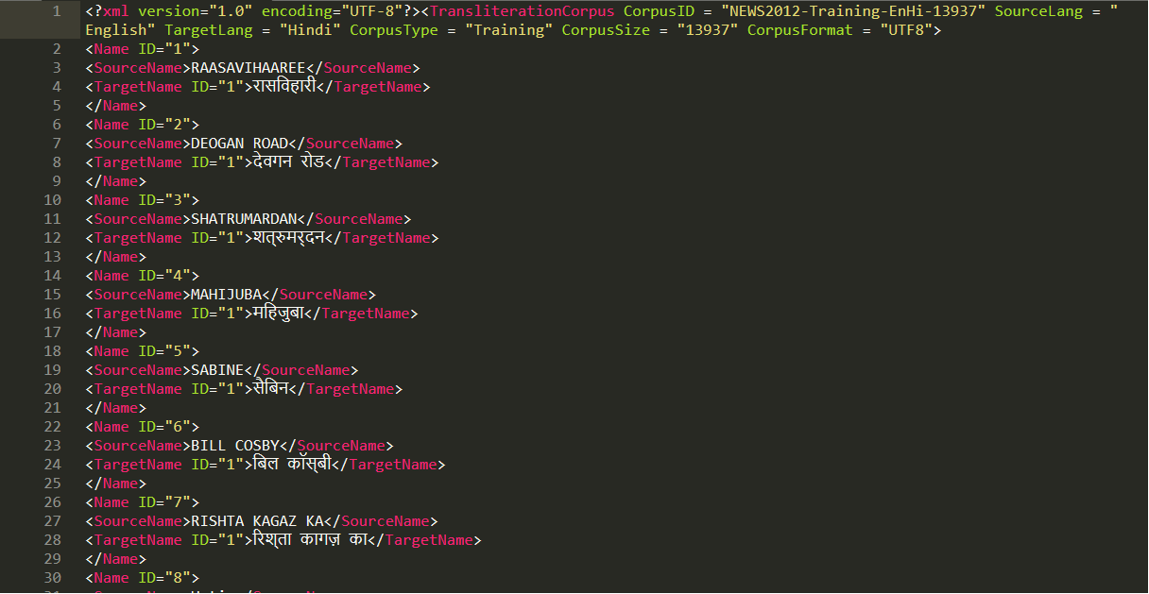

Figure 5 Transliteration Dataset

**3.1.2 Text Detection**

For the text detection task, we have decided to go with a pretrained model from the model zoo of the Detectron2 kit, specifically the FasterRCNN model (faster_rcnn_R_50_FPN_3x) model with Feature Pyramid Network (FPN; for tightening bounding boxes). This model has been trained on the COCO Dataset for object detection, but we can fine-tune it by doing further training on our model.

A RCNN is an neural network which is trained for both classification and detection of objects in images. It involves a region proposal stage which divides the images to regions-of-interest (ROI) based on some clustering algorithm (which can be both static aur trainable) and some threshold, then a feature extraction stage in which Convolutional Neural Network layers are used to learn meaningful patters from the ROI, before finally passing the extracted features both to a classifier (traditionally an SVM, but a feedforward neural network with softmax output can also be used), and a regression network, where the bounding boxes of the object (if there is a classified object) are learned as a regression problem.

In the case of this particular model, it uses a ResNet as it’s backbone CNN, a Region Proposal Network for proposing ROI, and a Box Head for performing regression task to extract bounding boxes.

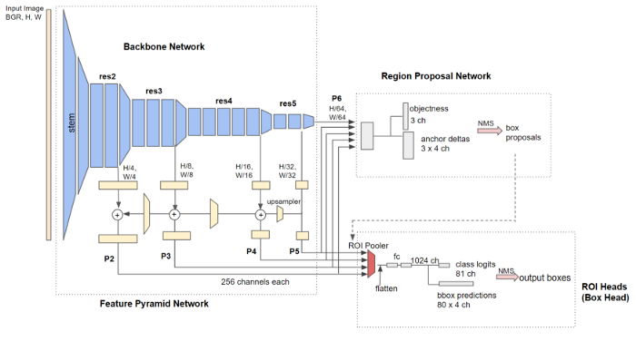

Figure 6 Detectron2 Faster RCNN

Furthermore, since we are only interested in obtaining the bounding boxes of the text from this model, we set the class of all annotations of the training to a single class (in this case, ‘Hindi’), and extract the bouding box coordinates as output. The image is then cropped to these bounding box coordinates, and this cropped-bounding-box is fed as input to the next model.

**3.1.3 Text Recognition**

For the text recognition task, we use an encoder-decoder architecture to extract the ground truth script from the cropped bounding box input.

An encoder-decoder architecture is a two-model architecture. The encoder network takes the input to the model and converts it to an intermediate form, while the decoder network then takes this intermediate form as input and produces the target output.

For this model, the encoder is a Convolutional Neural Network (CNN), while the decoder is a Gated Recurrent Unit(GRU). A GRU is a recurrent neural network with information controlling gates, used to deal with variable inputs or inputs that can be represented as a series of timesteps. In this case, a script word is a variable sequence, where every letter in the word can be taken as a timestep. Connectionist Temporal Classifification (CTC) loss will be used to eliminate duplicate recognition of the same letter by adjacent CNN features. Both models are taken from the torch.module packs.

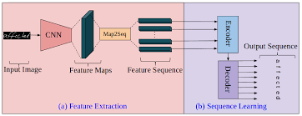

Figure 7 CNN-GRU Text Recognition Model

The text present in the image, in the source language script is output by this model. This string is converted to a one-hot encoded tensor by letter (each character is a one-hot encoded vector, making this output word a tensor of vectors / tensors).. This tensor is then fed to the next and final model as input.

**3.1.4 Text Transliteration**

For the text transliteration task, we use yet another encoder-decoder architecture, but this time both the encoder and decoder models are GRUs, since we are dealing with a sequence-to-sequence generation problem.

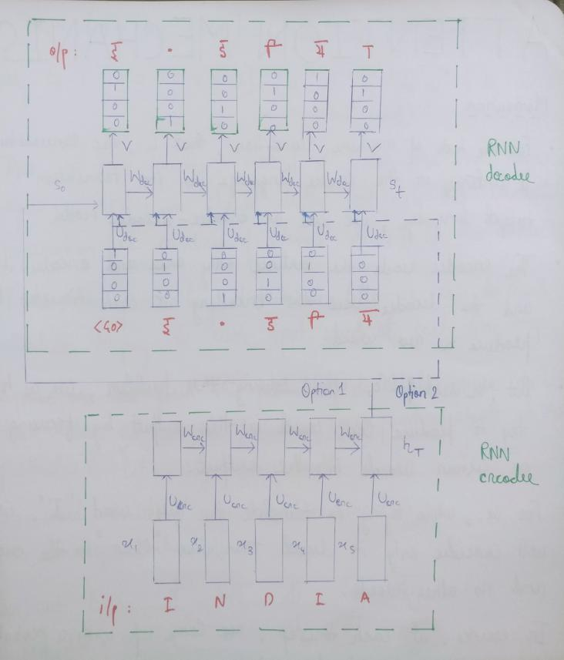

Figure 8 GRU-GRU Text Transliteration Architecture

The source language word, represented as the tensor of tensors, is converted to an intermediate form by the encoder model. From this, the decoder model learns to generate another tensor of one-hot encoded tensors as output. When the one-hot encoding is reversed, we get the output as the corresponding transliteration of source script into target script.

**3.2 Android App**

The models will now be deployed onto an Android app. This app will be developed using Java. The models will be deployed using Tensorflow Lite.

Tensorflow Lite is an open-source framework for on-device inference using models weights saved as tensors. After training, the models weights are checkpointed and saved, then converted into .tflite files by utilizing Tensorflow Lite’s Converter, and then deployed onto the app as a package for a function to run inference from.

The app will function as this- the user will click the photo of a signboard, or a road sign, or a shop sign, etc. with some selected source language script. The image will then be captured and sent to the model framework for capturing the text in the image. If some text is detected within a threshold, the model framework will extract and transliterate the text into the target language, and display it to the user.

The app will also use Google Firebase API to provide user functionality and interface.

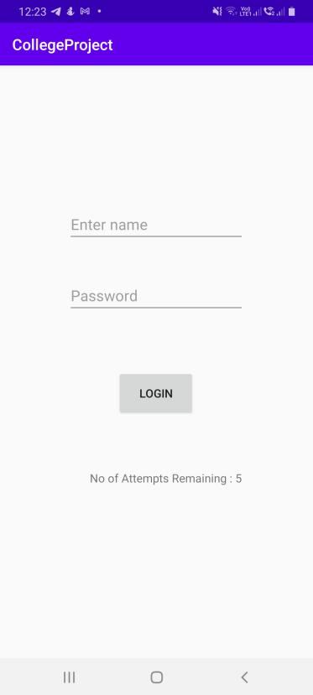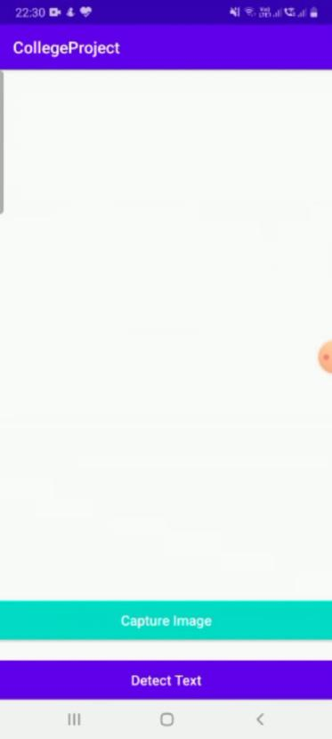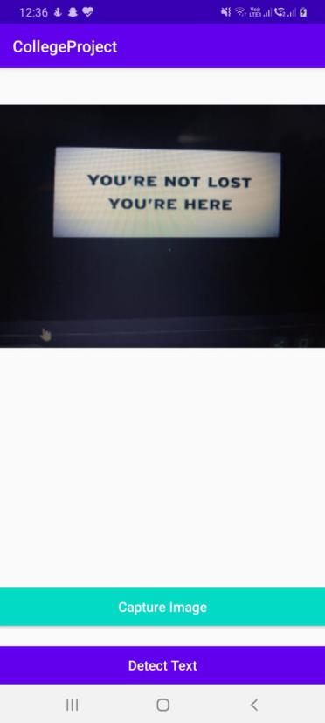

Figure 9: App Interface

**CHAPTER 4**

**SYSTEM ARCHITECTURE**

The basic functioning of the app is as follows:

1. User captures a photo of the signboard
2. The image is resized so as to be suitable as input to the model
3. The model takes the image as input. The text within the message is detected, extracted and transcribed to target language.
4. The text output (or error message, in case of failure to generate output within threshold confidence), is displayed on screen.

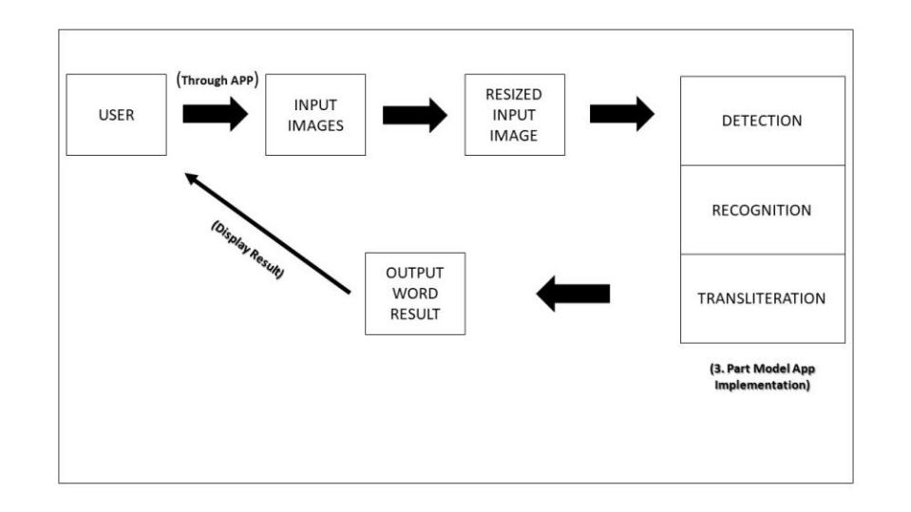

Figure 10: App Architecture

The artifificial neural network (ANN) behind the core functioning of the app is made up of 3 models performing consecutive tasks. That is, the output of a preceding model will be fed as input to the succeeding model, and thus they act as one model unit.

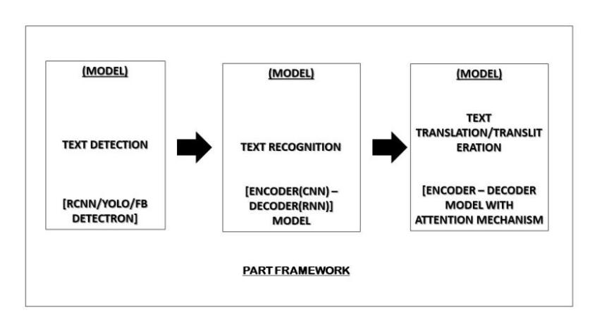

Figure 11: Model Architecture

**CHAPTER 5**

**PROJECT CODE AND RESULTS**

**MODEL**

**Text Detection and Recognition**:

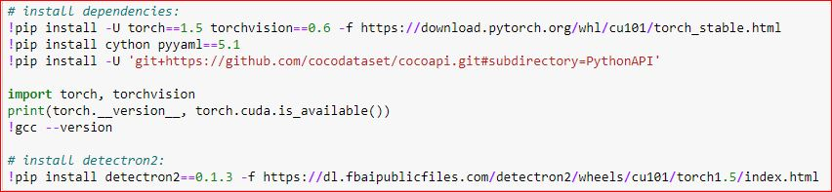

Importing Libraries:

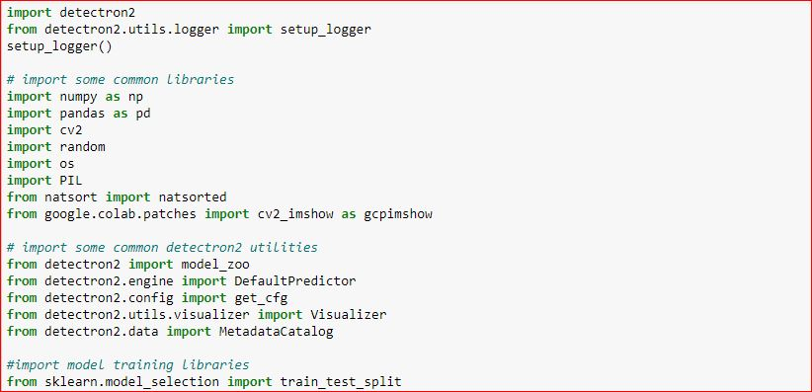

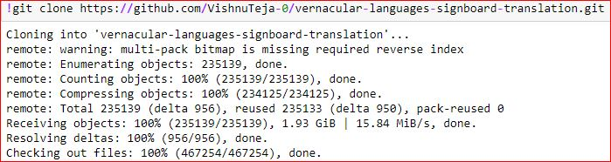

Dataset Preparation:

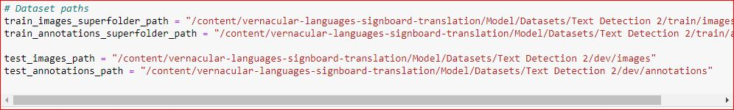



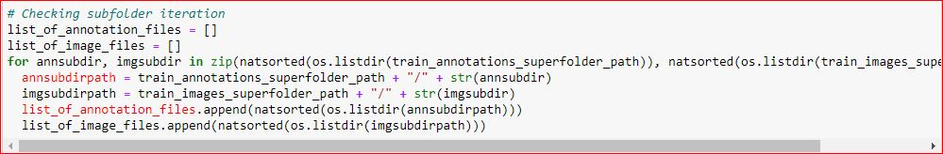

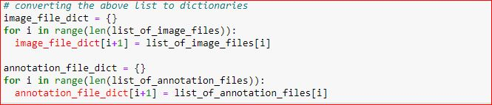

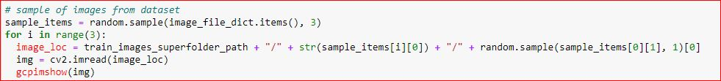

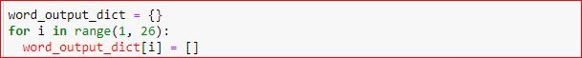

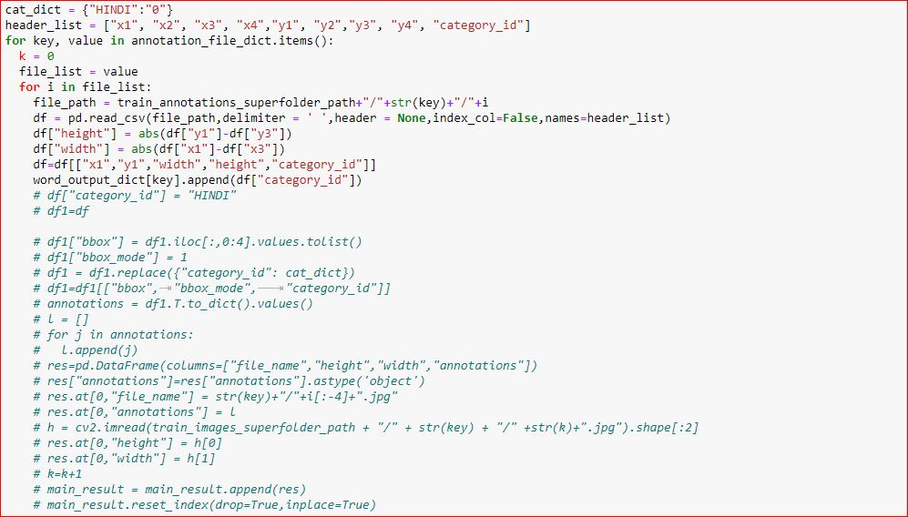

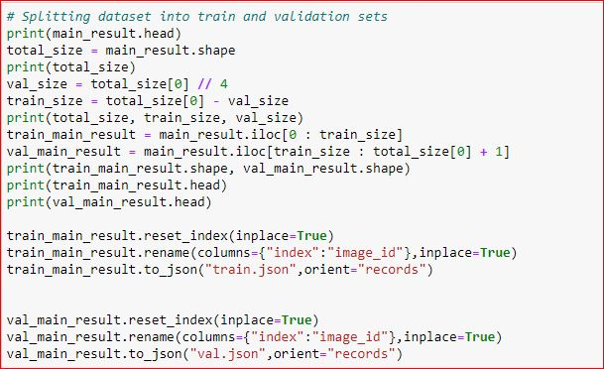

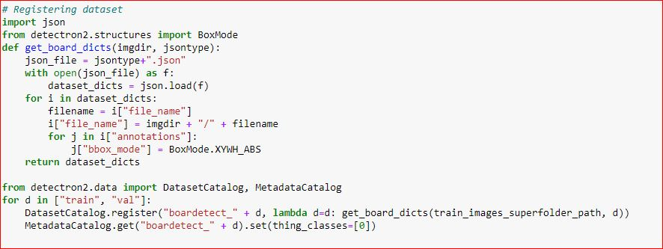

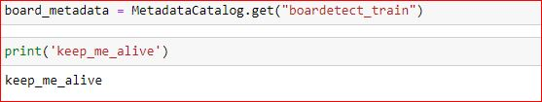

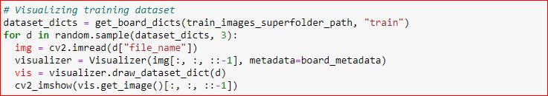

Training – Text Detection

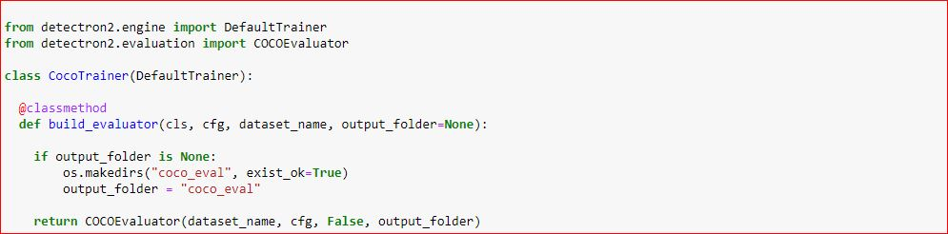

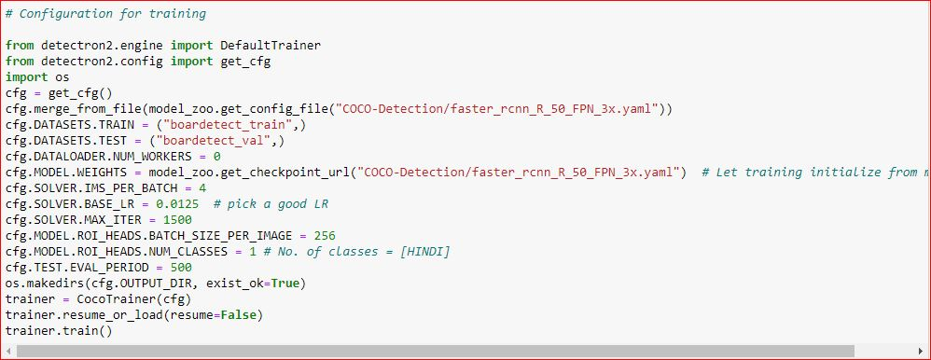

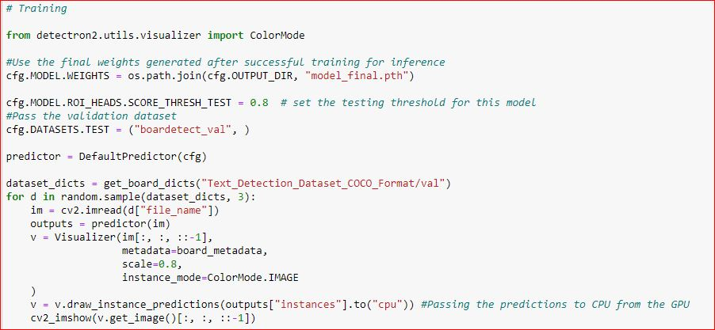

MODEL- TEXT RECOGNITION







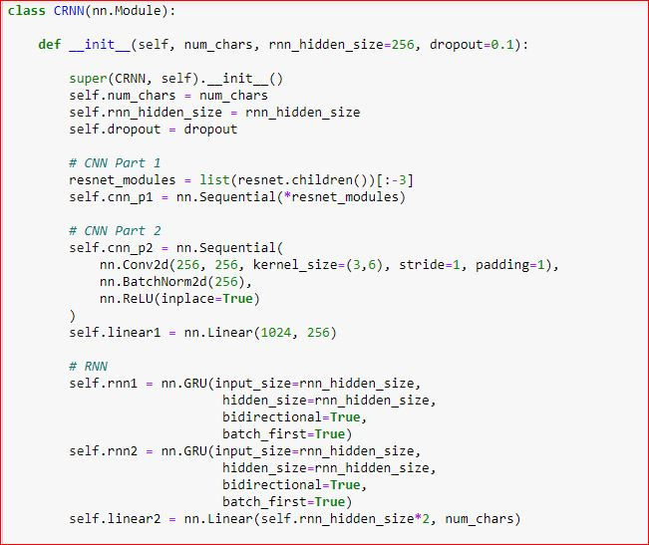

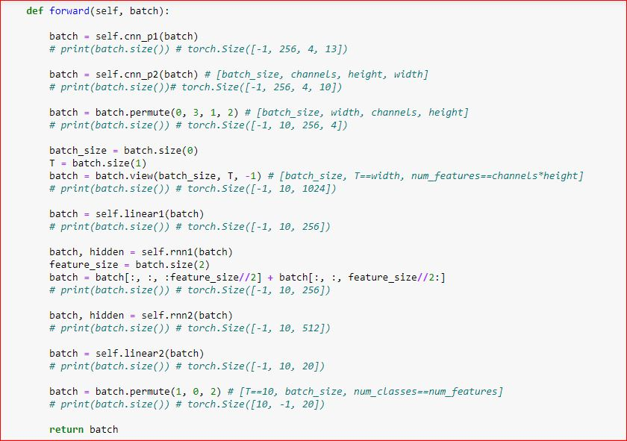



DATA PREPARATION- TEXT RECOGINITION

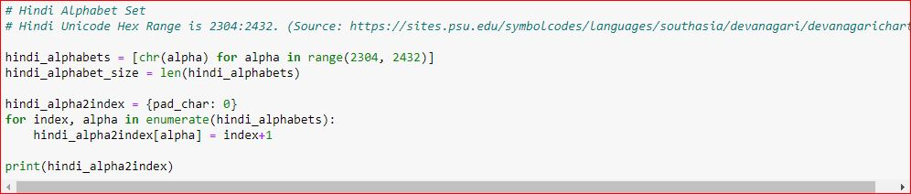

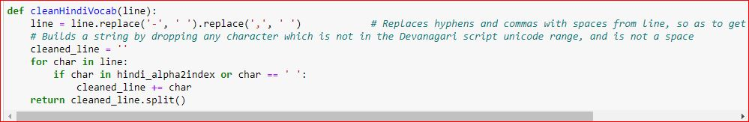

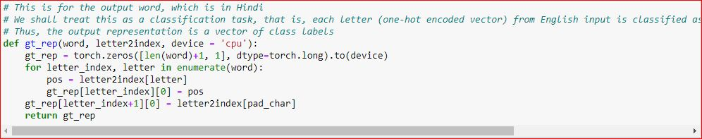

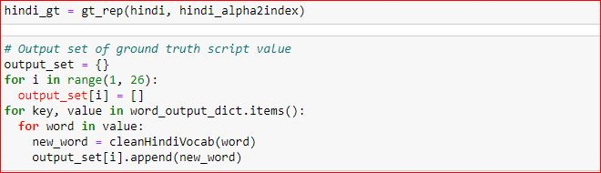

DEFINE LOSS



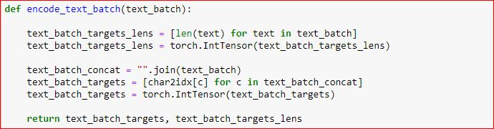

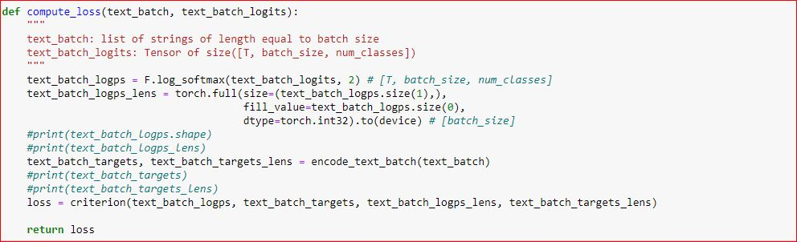



TRAINING- TEXT RECOGNITION

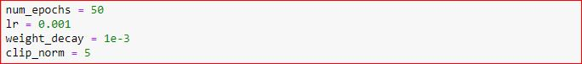



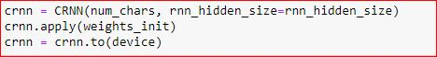

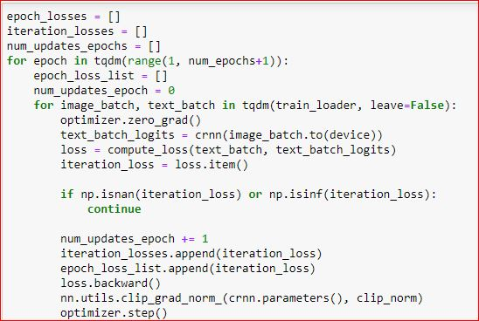

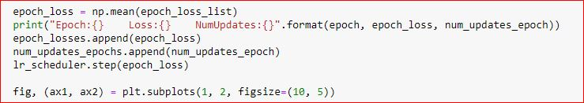

**TEXT TRANSLITERATION**

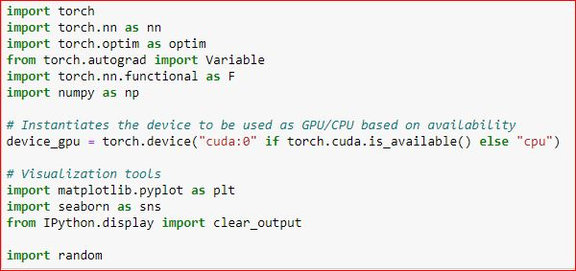

ALPHABETS SETUP

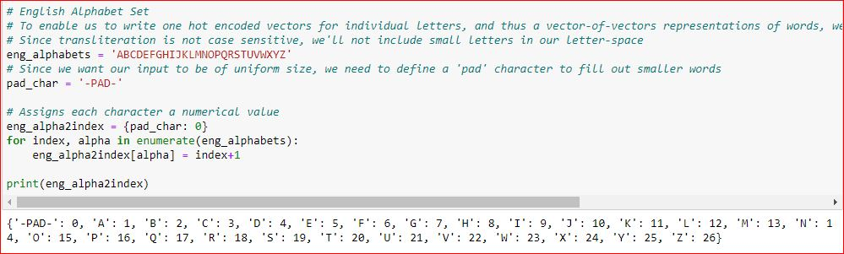

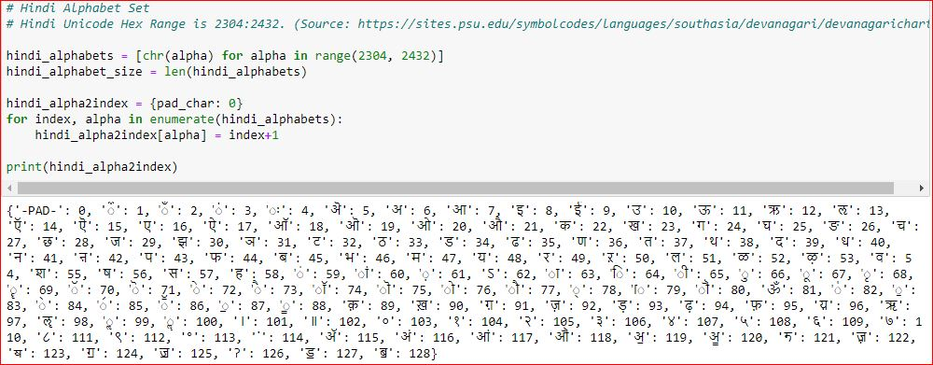

HELPER FUNCTIONS FOR DATA PRE-PROCESSING

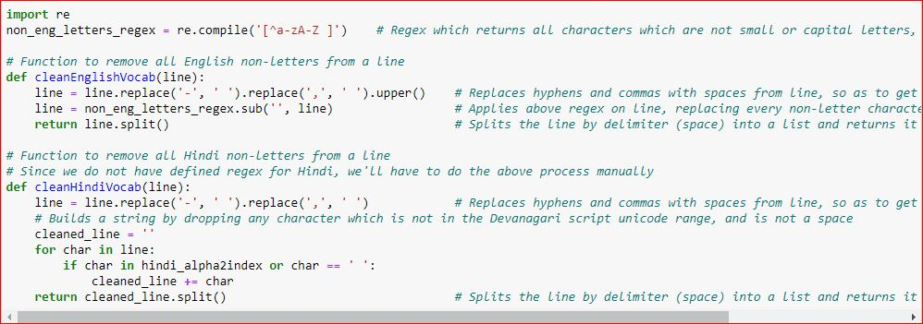

DATASET LOADING

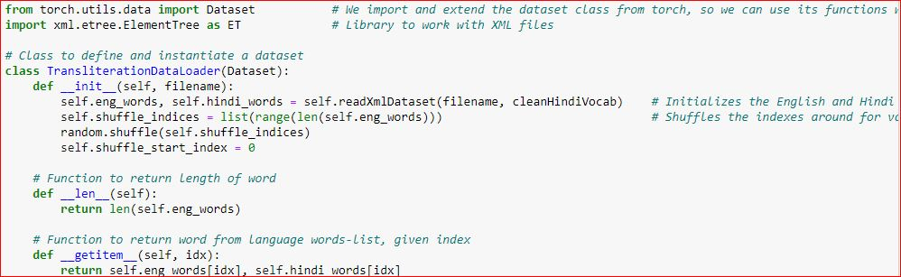

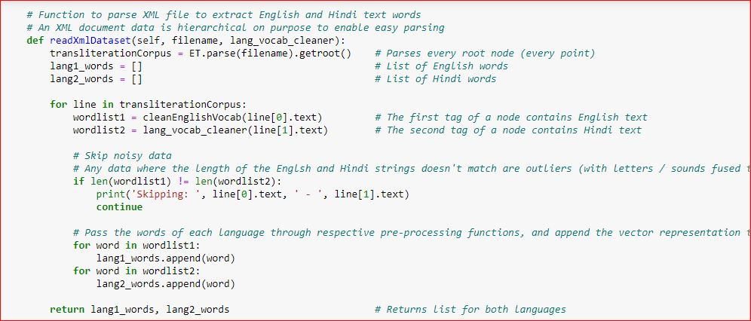

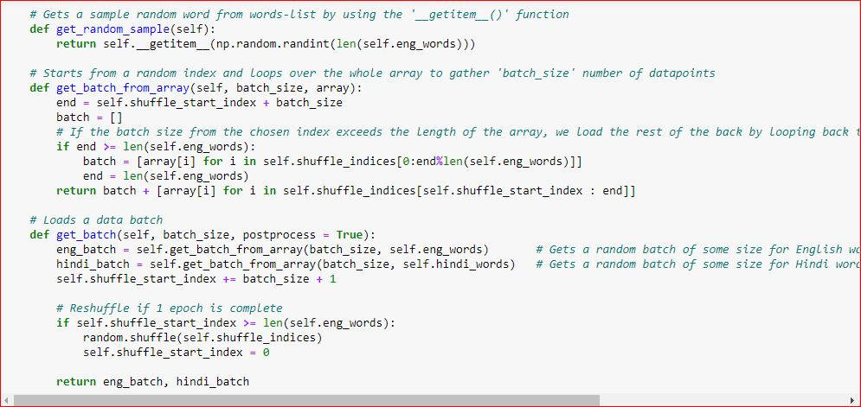

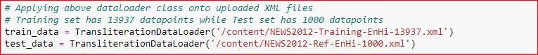

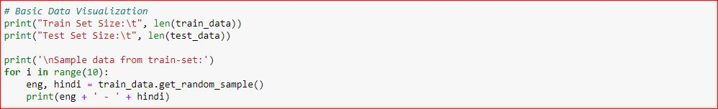

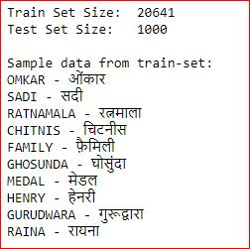

ENCODING WORDS

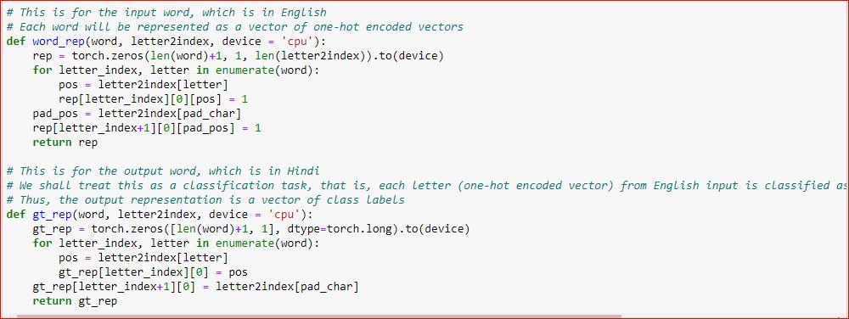

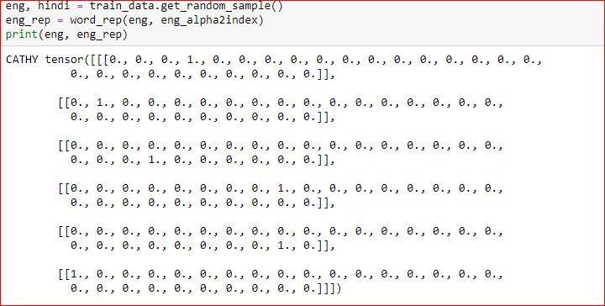

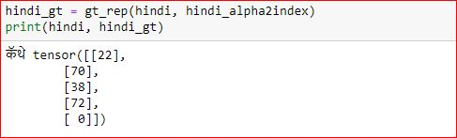

NETWORK ARCHITECTURE

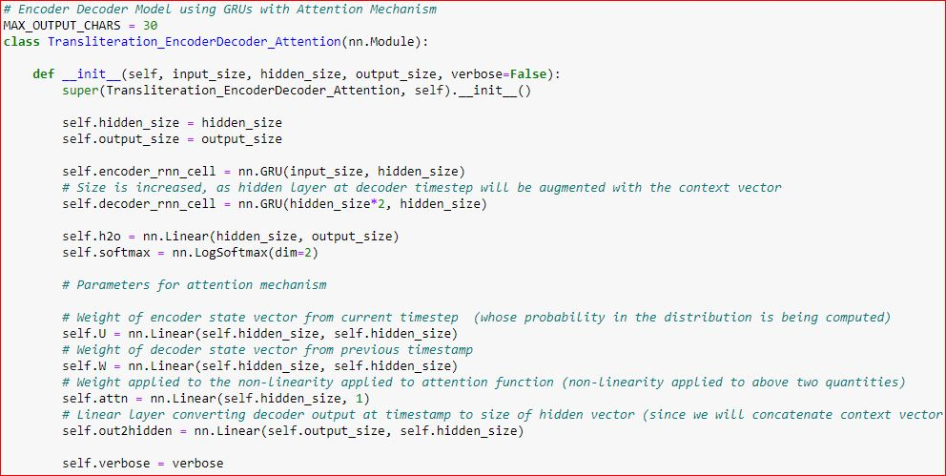

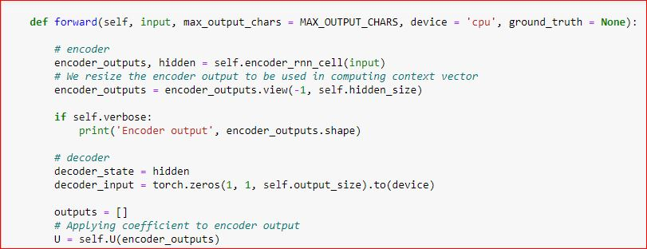

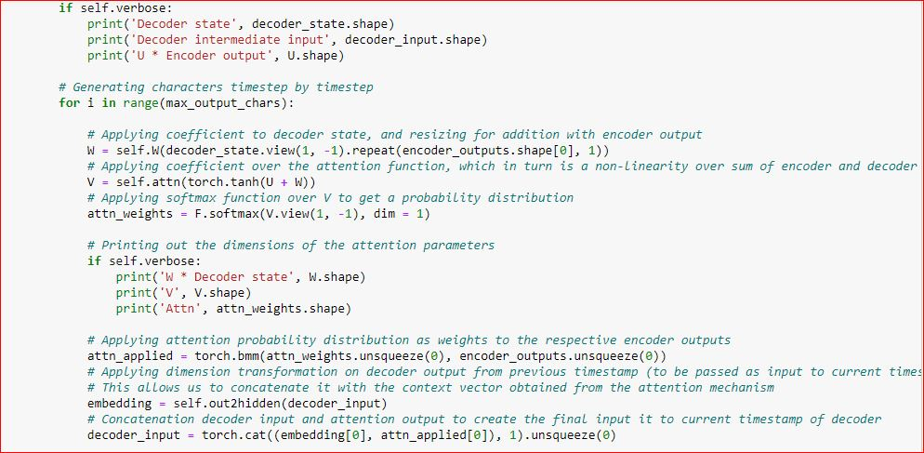

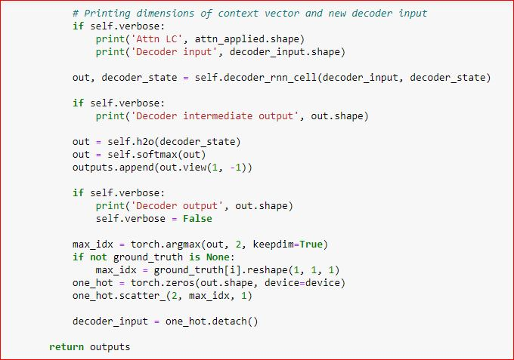



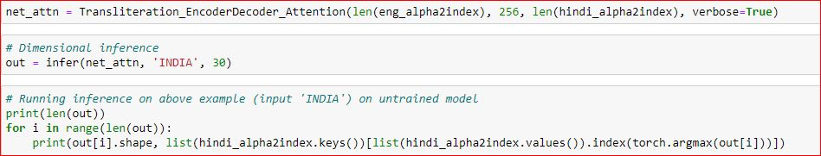

TRAINING

CORE TRAINER

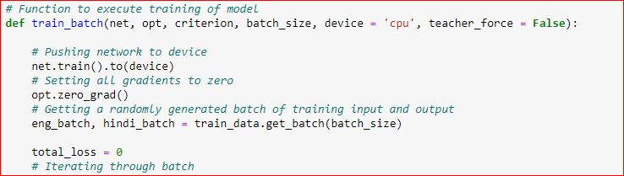

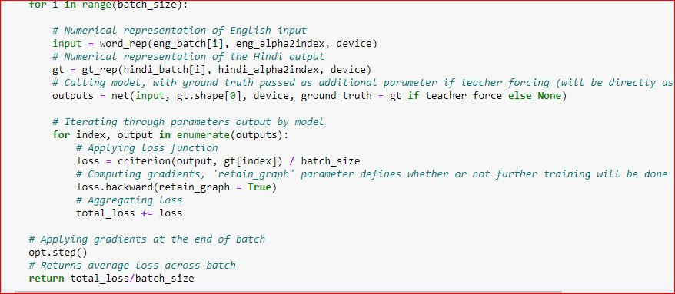

TRAINING HELPER

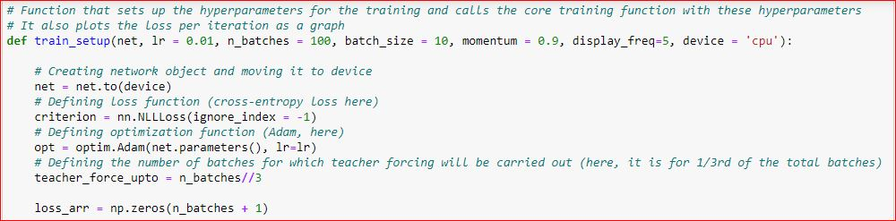

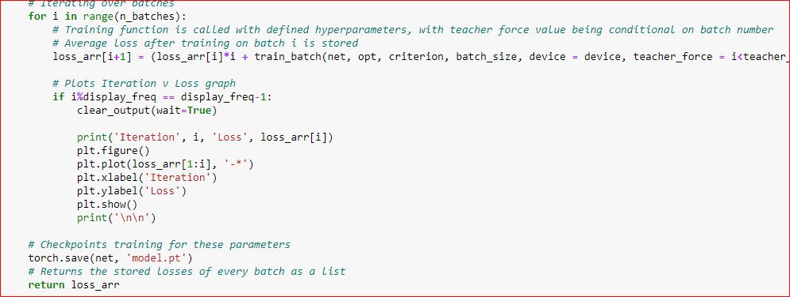

TRAINING



INFERENCE

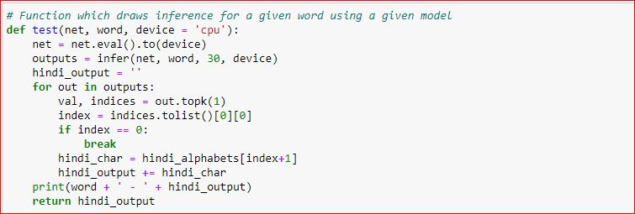

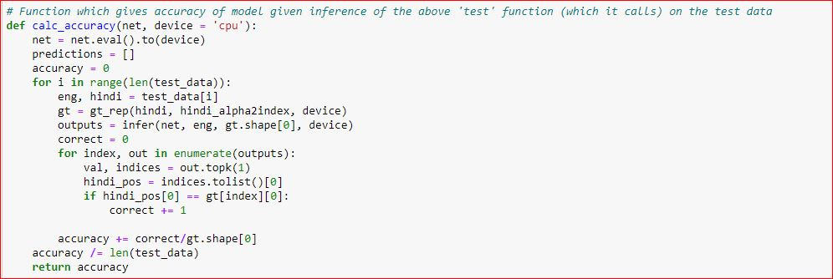



**Accuracy Results**

Text Detection:

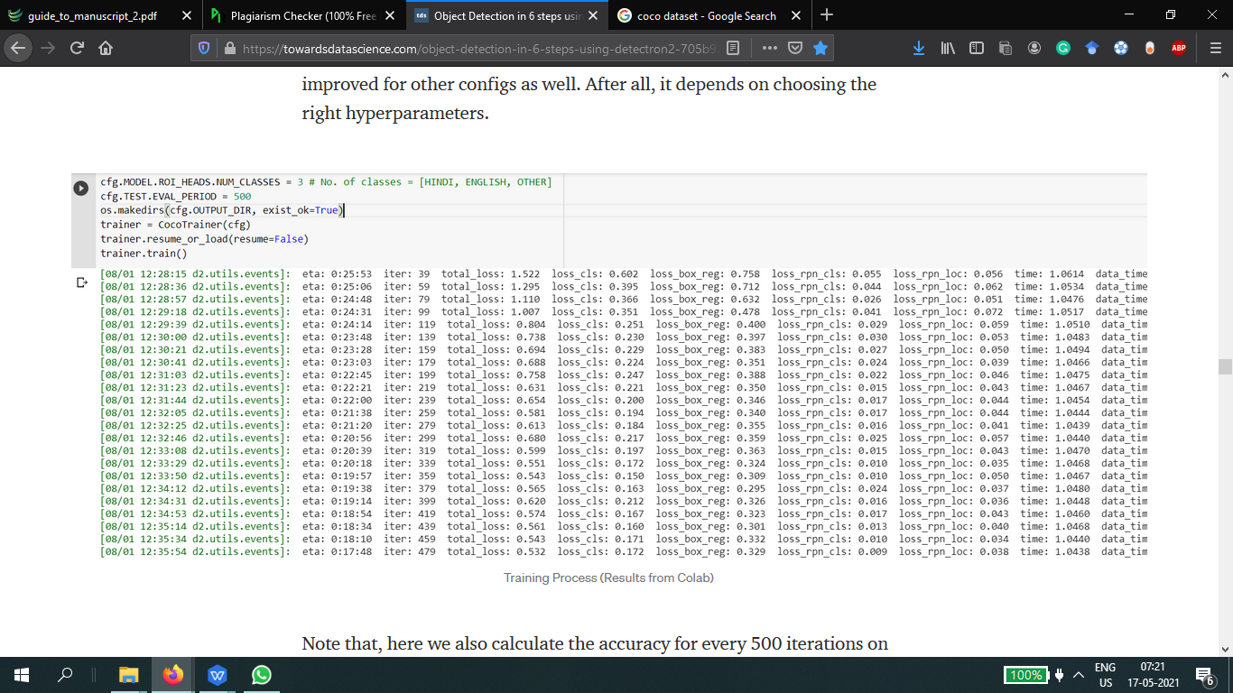

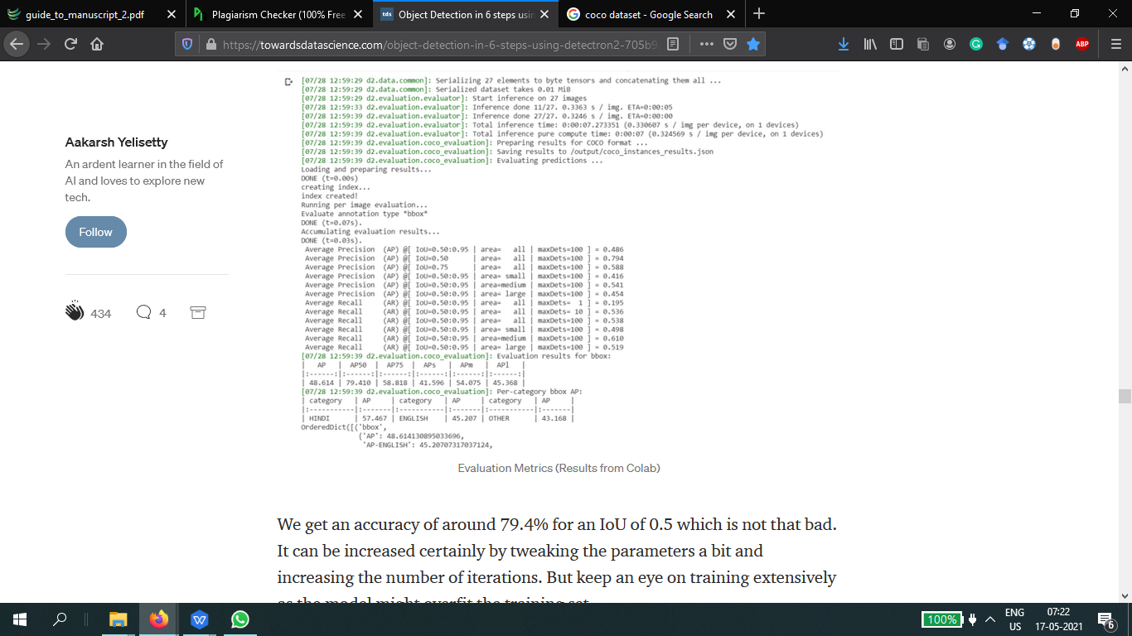

Text Recognition

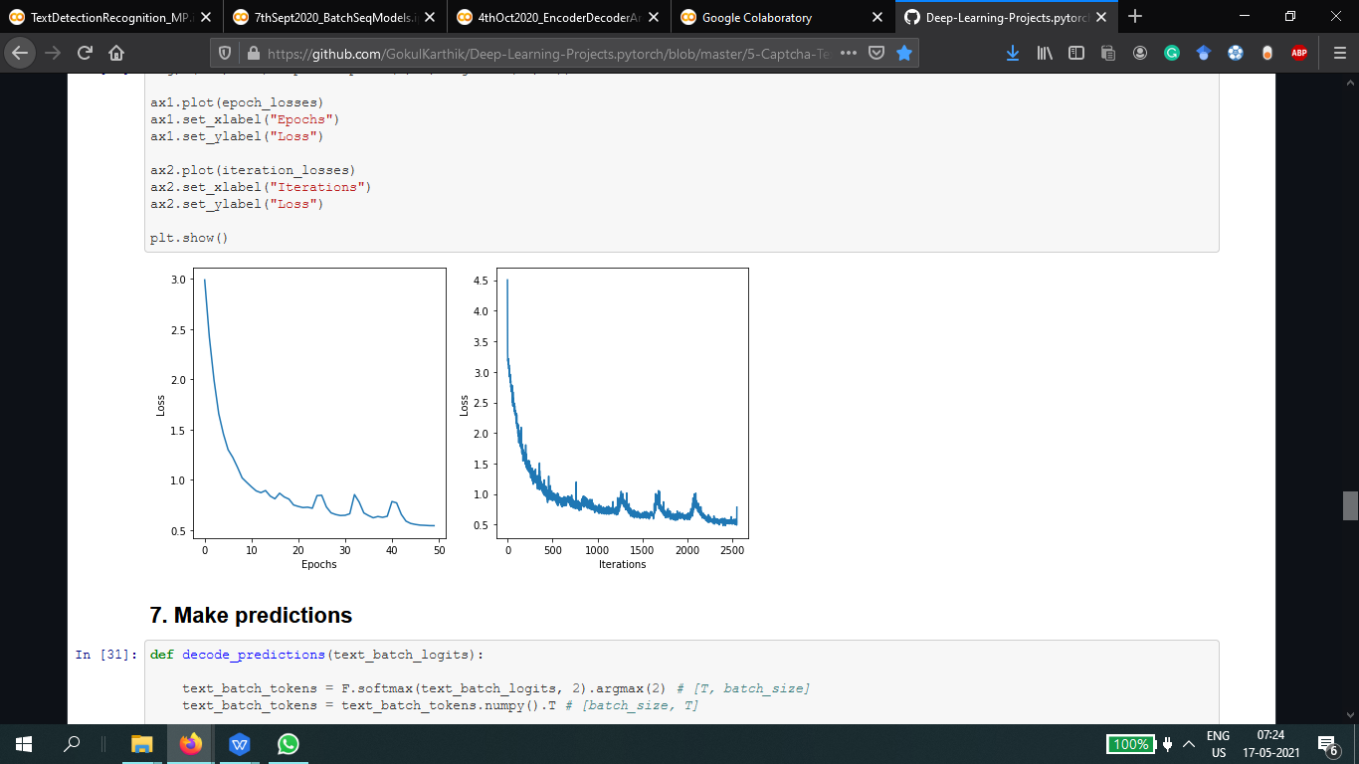

Text Transliteration

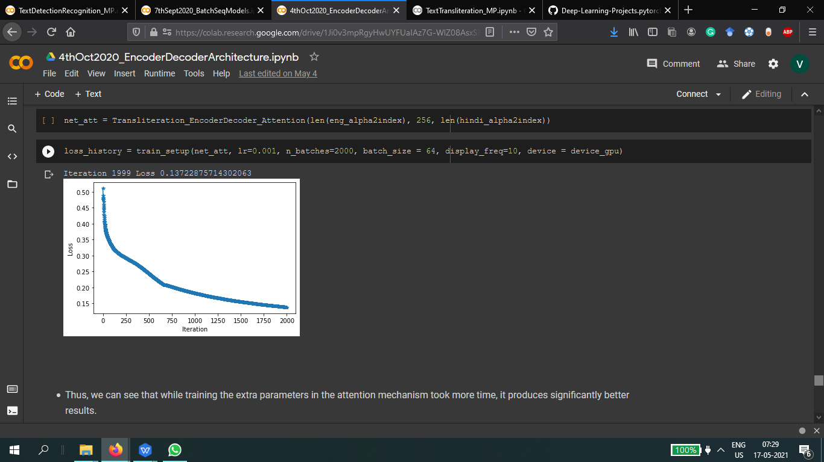

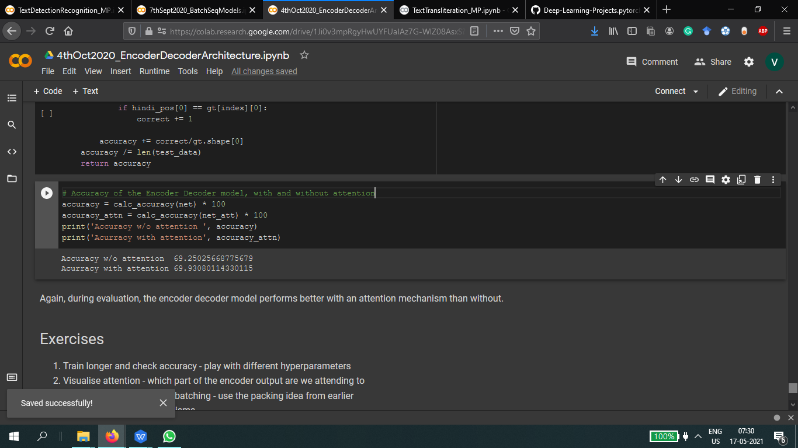

**ANDROID APP**

Build Gradle:

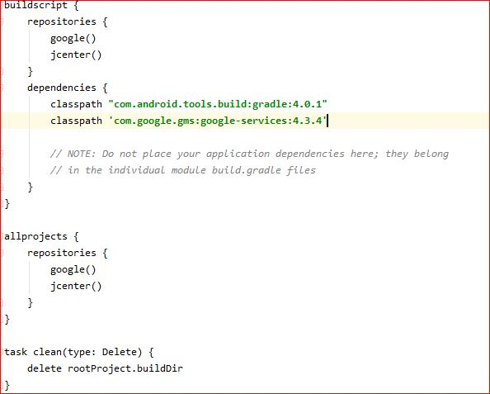

Dependencies:

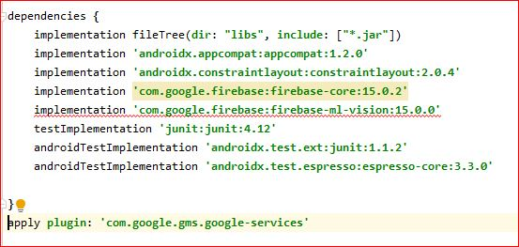

**XML Files**:

Main Activity

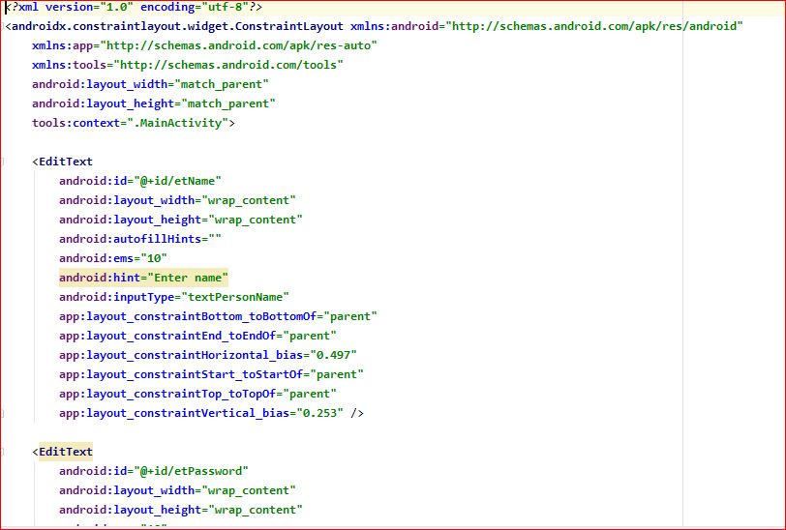

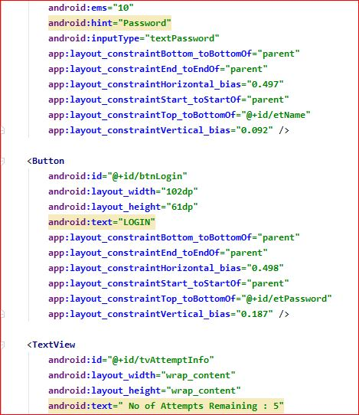

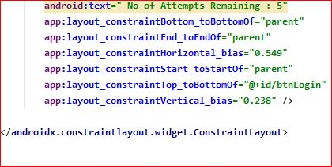

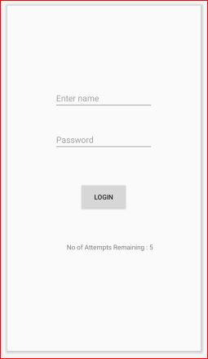

UI FOR LOGIN

1. Text Recognition Screen:

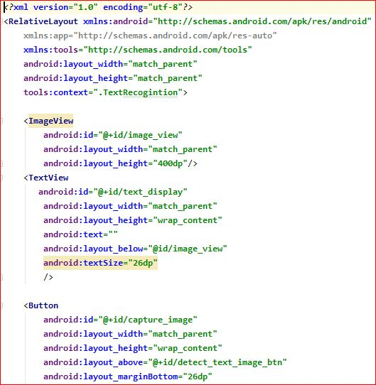

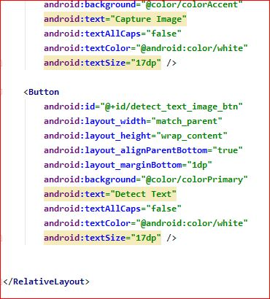

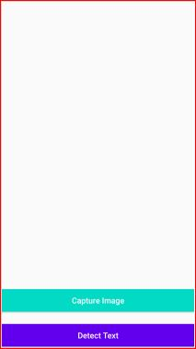

UI FOR CAPTURE IMAGE

3.JAVA Code for Main Login Screen

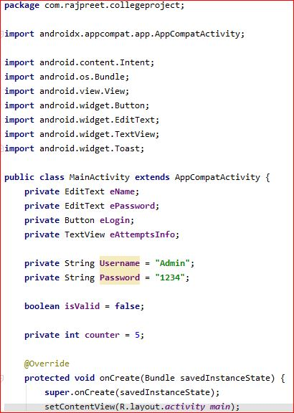

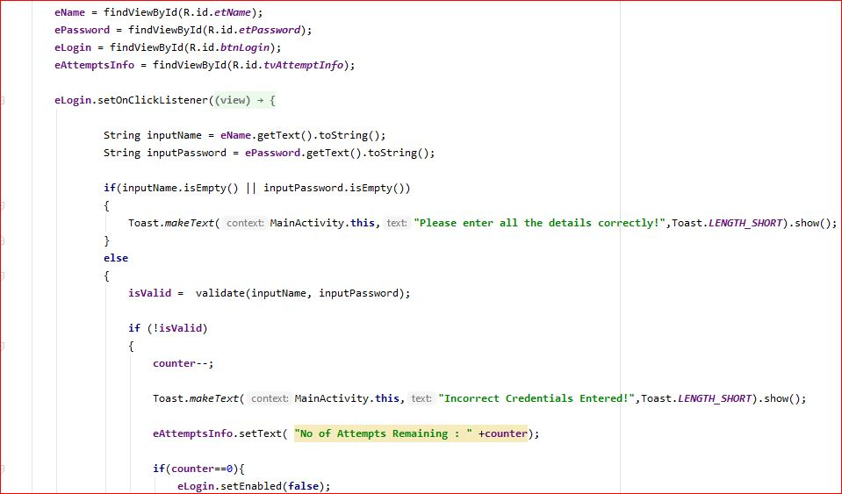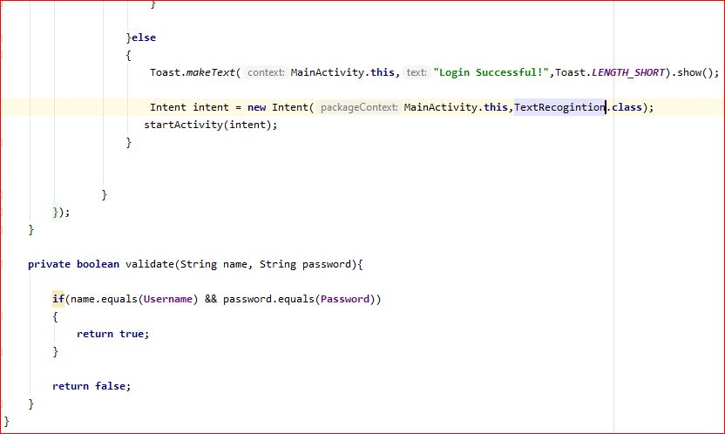

4. Text Recognition Code:

The below code is for the declaration of the buttons and the variables:

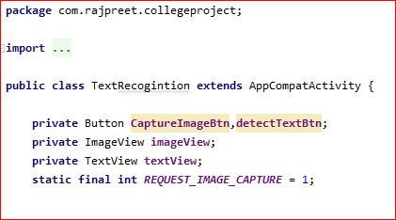

This code is to call the buttons from the xml document and initialize them :

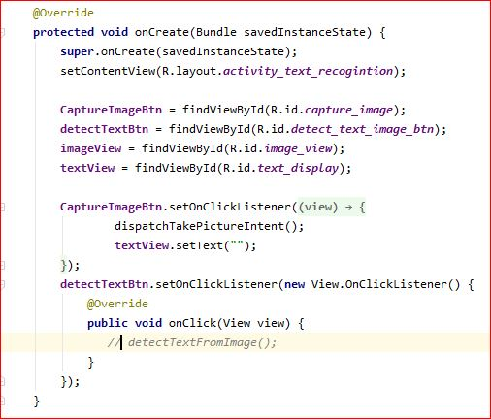

This code is to take the permission of the user to use camera to capture the image:

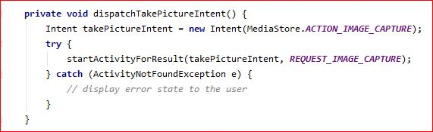

Following code displays the text captured from the image and thus use it as an input to our model.

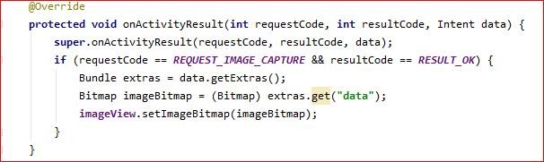

**CHAPTER 6**

**CONCLUSION**

The rapid dissemination of infomation in digital format, coupled with the complexities of having such linguistic diversity in our nation, necessitate the development of computer vision and natural language processing models which facilitate communication across languages.

It is also imperative that these solutions be scalable, accessible and distributable to serve the large population of our country.

The aim of the project, to develop a signboard translation system, was an example of how deep learning and artificial neural networks can be harnessed to make life more convenient. It is a simple app which detects, extracts and translates from source to target language, text captured as part of a natural scene by a user, and can be especially useful to interstate and international travellers. Various neural network models were used to train on a set of synthetically generated and curated data and the best performing model, given the time constraints, was selected for evaluation. However, these models, even in this limited scope, still have room for improvement using more diverse testing and use of techniques such as dropout,batch normalization, ensemble modelling, etc.

**CHAPTER 7**

**SCOPE FOR FUTURE**

The given model is successfully implementated with a modest accuracy, but this project was designed from the get-go to be scalable and improvable.

To start with, the training of the models could have been improved by using techniques such as regularization, dropout, batch normalization and sequence batching to achieve even higher training and testing accuracy. The model could have been further tested on a more diverse range of natural scene images.

This project can also be extended to work with longer sequences of text, and in particular, other languages. Though we have used Hindi and English here as source and target languages, this same model framework can be trained for any combination of source and target languages, given an appropriate curation of dataset. These can then be made available to the user of the app as downloadable packs.

While this project features the raw programming of the models, a long-term view of this project will be to make an easy-to-use API, so that, given the datasets, other developers using natural scene detection, recognition and transliteration as a part of their projects (for example, detection of labels from medicine bottles, or very accurate newsreader apps) can easily train and deploy models.

The app itself can be added to in terms of functionality, and developing a user log-in system, improving UI, history of captured images and their translations, etc. are some features that can be implemented.

**REFERENCES**

1. C. Kurian and K. Kannan Balakrishnan.(2008). “Natural language processing in india prospects and challanges”.*In Proceedings of the International Conference on “Recent Trends in Computational Science.*
2. ORGI. ["Census of India: Comparative speaker's strength of Scheduled Languages-1951, 1961, 1971, 1981, 1991 ,2001 and 2011"](http://www.censusindia.gov.in/2011Census/C-16_25062018_NEW.pdf)
3. N. P. Desai and V. K. Dabhi. (2021) “Taxonomic survey of hindi language NLP systems”, *arXiv preprint arXiv:2102.00214,*
4. J. Philip, V. P. Namboodiri, and C. Jawahar (2019), “A baseline neural machine translation system for indian languages”, *arXiv preprint arXiv:1907.12437*.
5. M. Rosca and T. Breuel. (2016) ”Sequence-to-sequence neural network models for transliteration.”. *arXiv preprint arXiv:1610.09565*.
6. T. Deselaers, S. Hasan, O. Bender, and H. Ney (2009). “A deep learning approach to machine transliteration”. *In Proceedings of the Fourth Workshop on Statistical Machine Translation, pages 233–241.*
7. A. Kunchukuttan, D. Kakwani, S. Golla, A. Bhattacharyya, M. M. Khapra, P. Kumar, et al. (2020). “Ai4bharat-indicnlp corpus: Monolingual corpora and word embeddings for indic languages.” *arXiv preprint arXiv:2005.00085.*
8. A. Sharma and D. Rattan.(2017) *“*Machine transliteration for indian languages: A review*.” International Journal of Advanced Research in Computer Science, 8(8),*
9. Bhanja, C. C., Bisharad, D., & Laskar, R. H. (2019). “Deep residual networks for pre-classification based Indian language identification*.” Journal of Intelligent & Fuzzy Systems, 36(3), 2207-2218.*
10. Arafat, S. Y., & Iqbal, M. J. (2020). “Urdu-text detection and recognition in natural scene images using deep learning*.” IEEE Access, 8, 96787-96803.*